Blueprint for Hammond Enclosure Drill

How to understand the Blueprint

1. Orientation is noted on the top right corner of the model image also the axes are helpful for knowing the orientation which are located on the bottom right and look like this: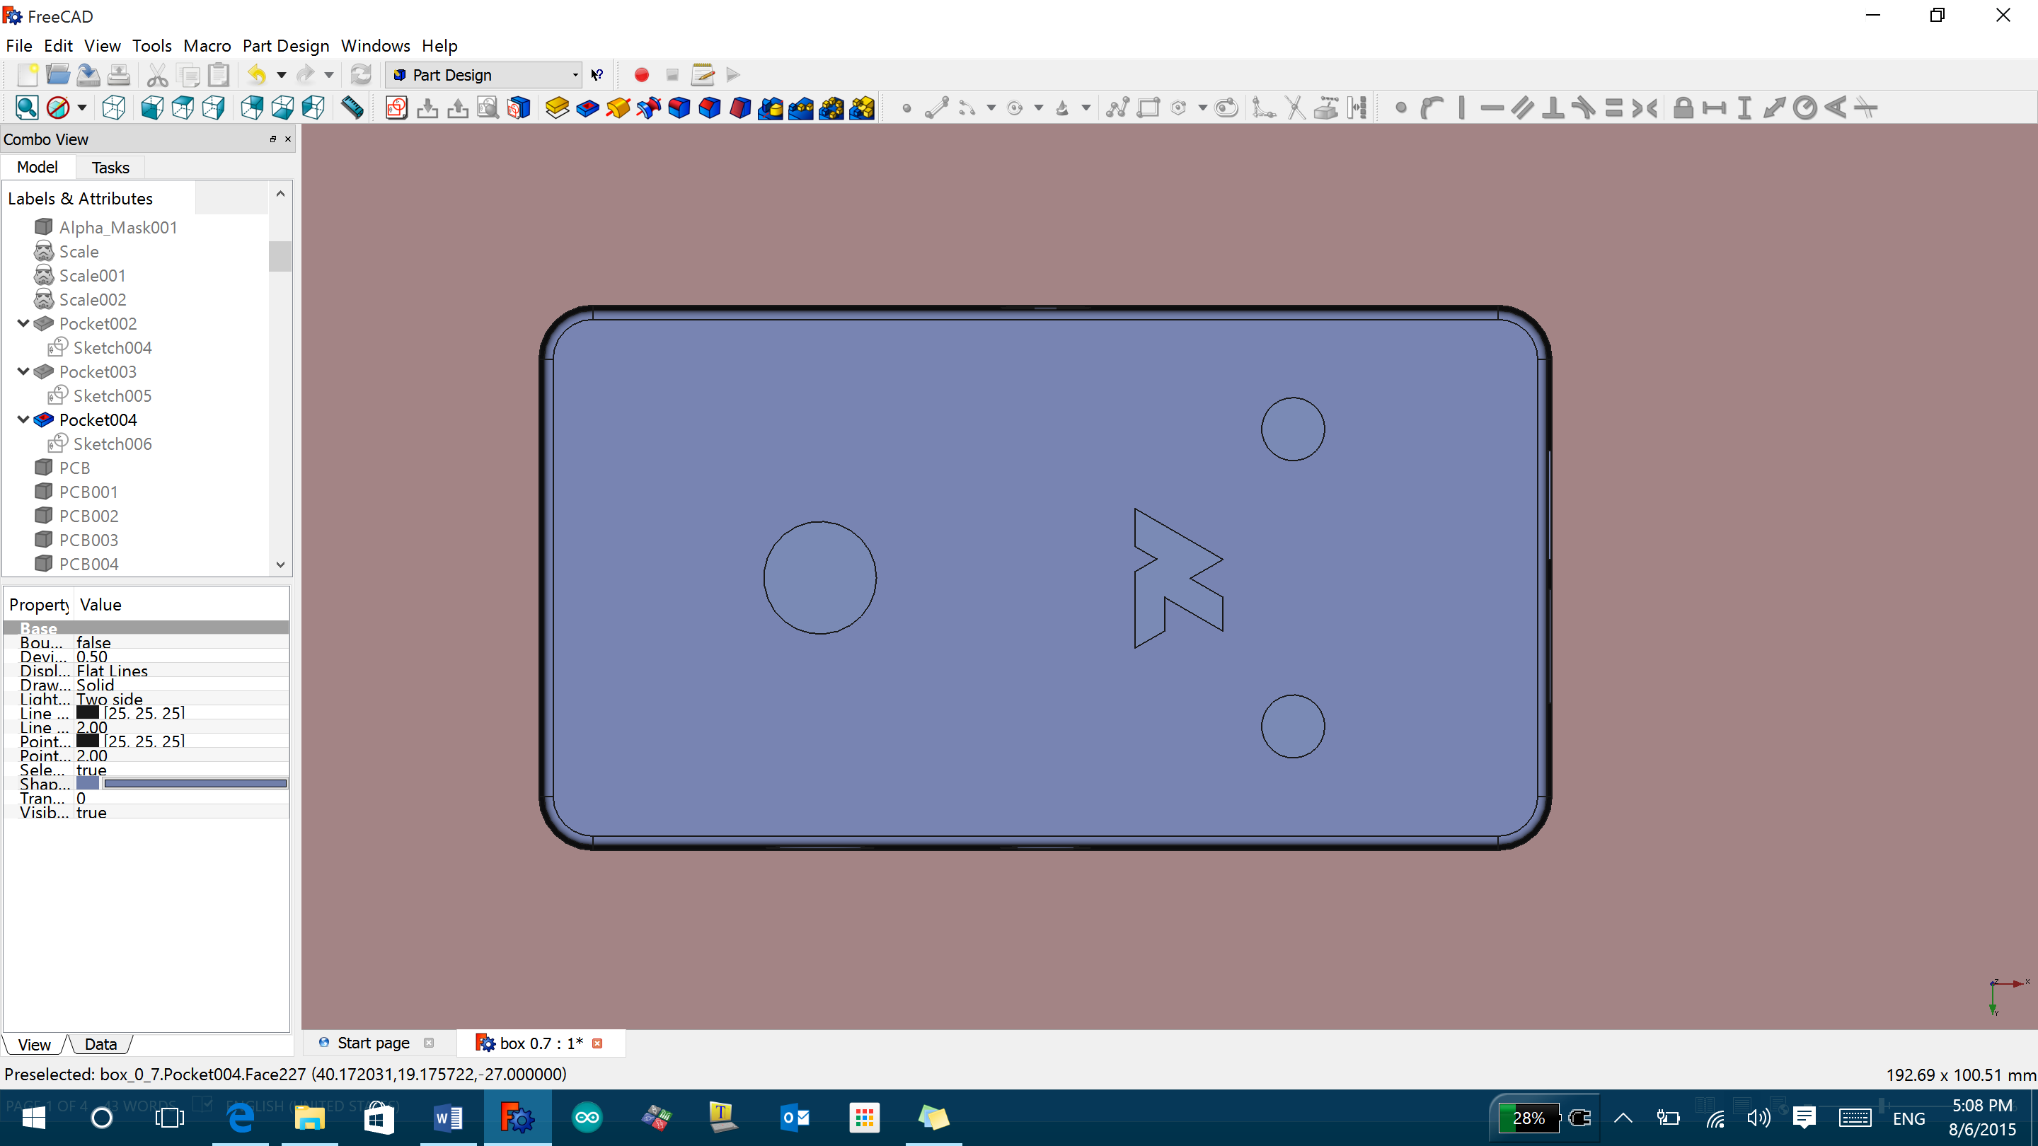
2. There is a center point dot located on each image as a reference point. This point is the absolute center of the top plane. However the dot sits on the bottom plane and all measurements to the side of the enclosure are based off of the bottom edge of the enclosure without the cover attached. The dot looks like this also the dot is not exactly placed on the image.
3. Logo on the top side of the enclosure is attached as a vector file. This blueprint only shows its location and dimensions.

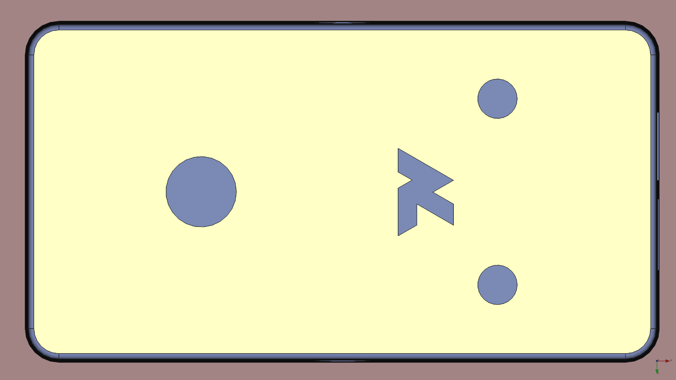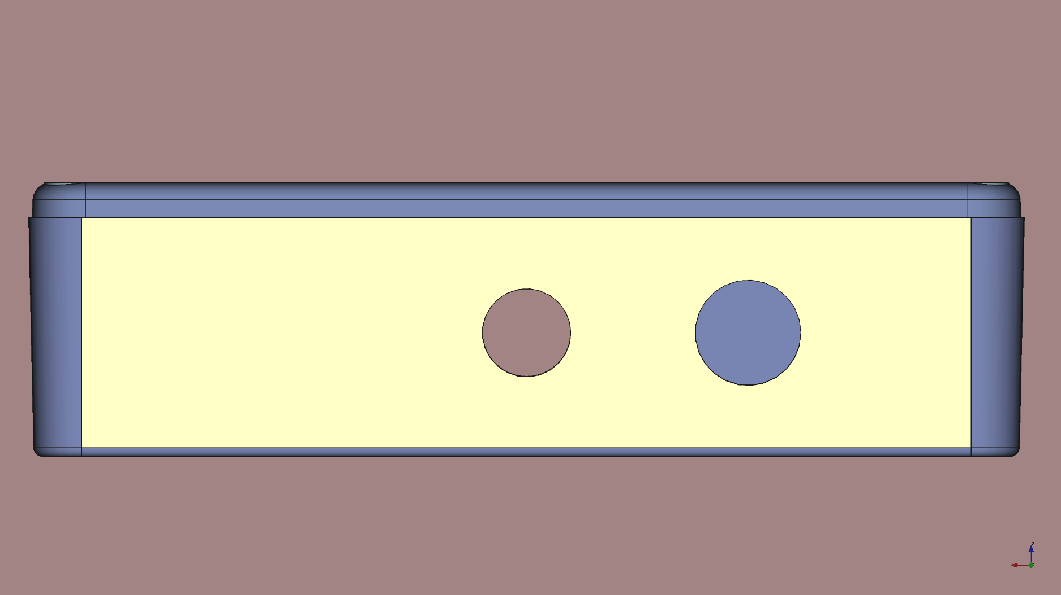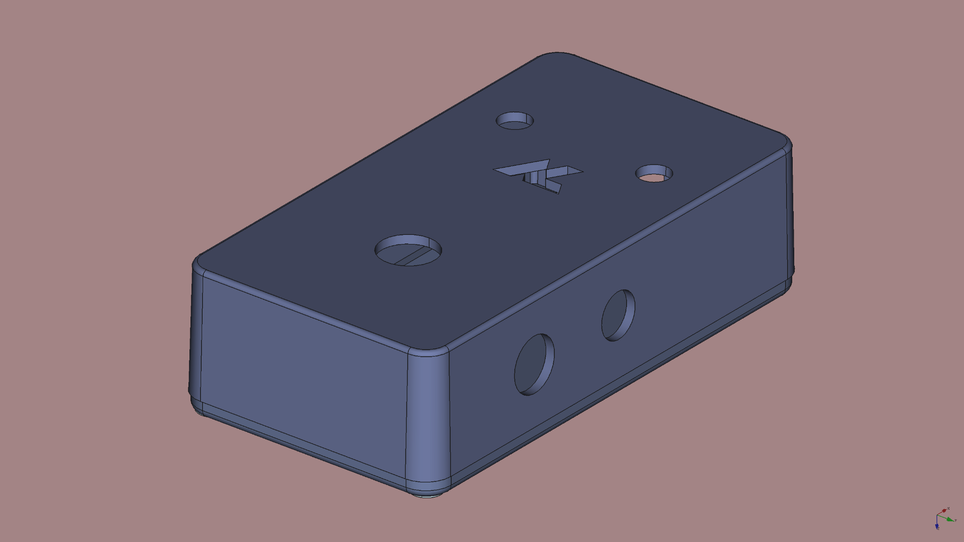

Middle hole is centered

25 mm

5.975 mm

5 mm

3.5 mm

12.3541 mm

12.3541 mm

RIGHT SIDE

TOP

Logo and 6.25mm radius hole are centered

3.5 mm

9.81 mm

9.91mm

15.5mm

16.5 mm

16.5 mm

27.5 mm

27.5 mm

6.25 mm

25mm

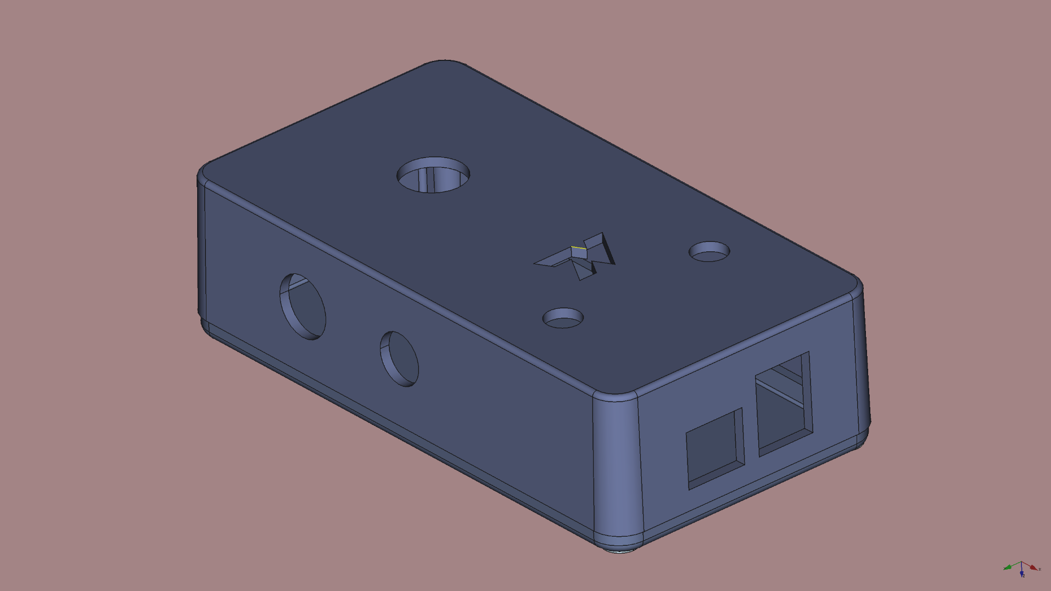

TOP

TOP

RIGHT SIDE

RIGHT SIDE

FRONT SIDE

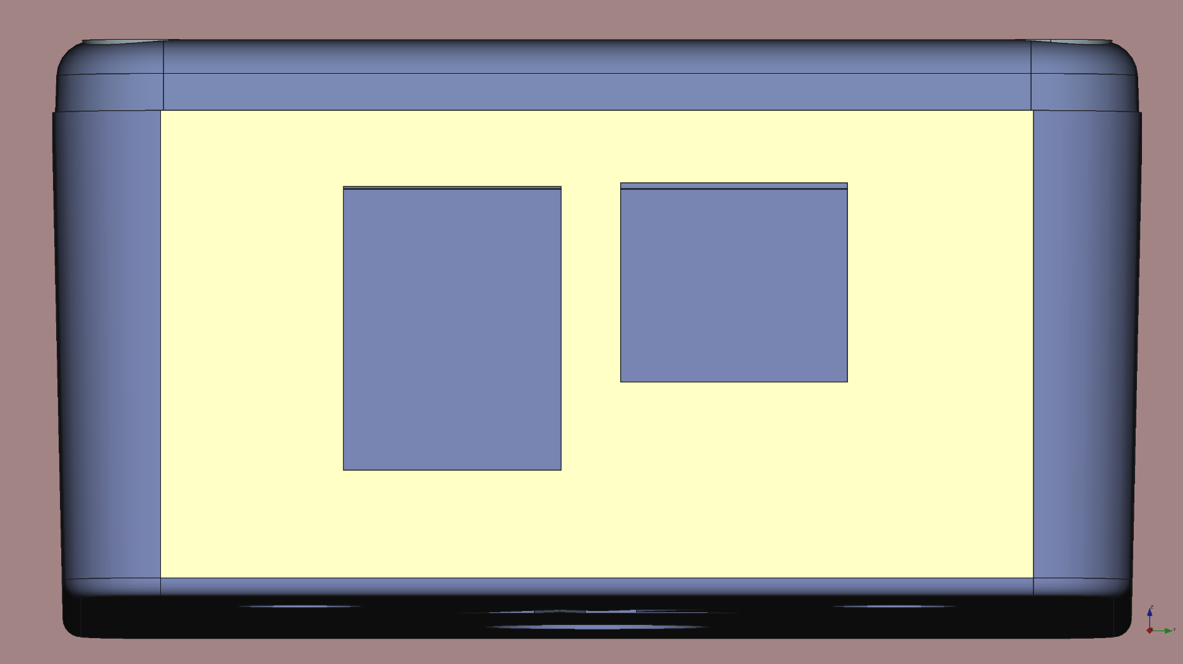

FRONT SIDE

5 mm

4 mm

1.3 mm

2 mm

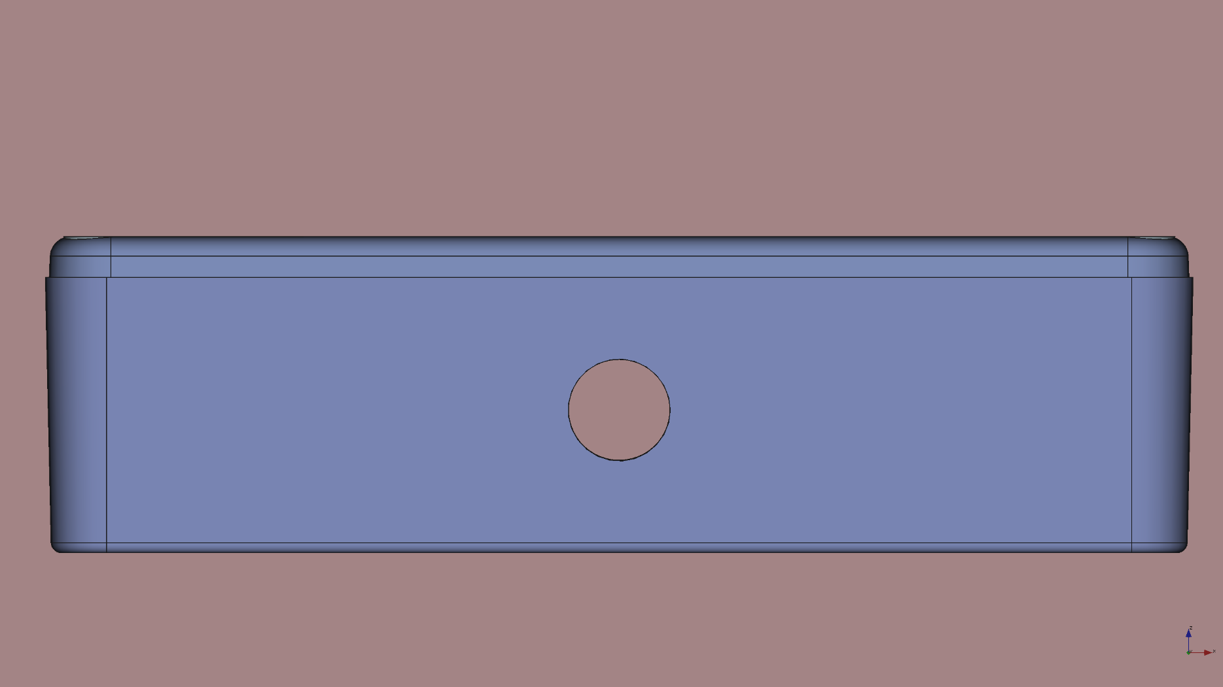

5 mm

12.3541 mm

LEFT SIDE

Middle hole is centered

11.1 mm

15.8 mm

12.1 mm

12.6 mm